**IT PAT**



**PHASE 1**

**hAMZAH VAHED**

**GRADE : 11 A**

**Problem Identification**

INFORMATION KIOSK

An information kiosk provides access to information that is both efficient and visually pleasing. It helps users make informed decisions and is generally targeted at places where there are large crowds such as shopping malls, airports, railway stations, game reserve, museums, etc. Information kiosks can also be interactive, for example, in a Game Reserve the public could enter a location where certain animals have been observed.

Choose an application/environment that where an information kiosk can be used and do research on the information system requirements.

**Report On Research**

**Digital kiosks** offer superior navigation features

Unlike the confusing static maps that used to be the standard, digital kiosks are intuitive, and can provide specific directions that allow individuals to get personalized directions.

**5 benefits of using retail kiosk applications**

* Improve customer buying experience. **Kiosks** provide customers with detailed information about the products and services offered by the retail company
* Increase customer base
* Reduce the cost of business.
* Gain efficiency through diverse applications.
* Boosts job satisfaction.

My aim is to design and program an application which is creative and will benefit the user making it easier for them to process data. This will also increase time management and productivity.

I started my research by interviewing a possible candidate who can maybe give me some background information on their job and of any problems they may be facing.

**Interview with Afzal**

1. Where do you work and what do you actually do?

* I am the co- owner of Autochoice. I help with sales and customers.

1. What are your main problems you came across?

* I find tracking meeting customers’ requirements challenging. I want them to easy find a car that suits them. It is also very challenging to keep to time and I have poor time management.

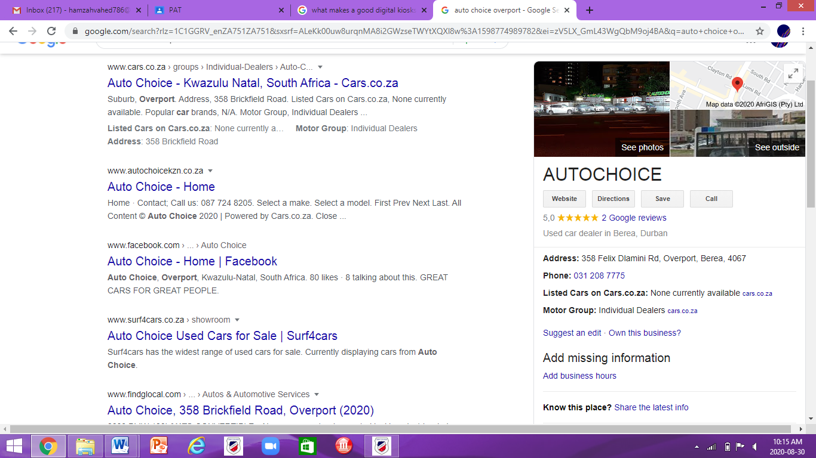

**Program Background Information**

**How the system will function**

My program will enable the user to search and output a suitable solution of the customer. This would speed up the treatment process and increase productivity and improves time management.

The program will have various different coding styles some being string manipulation, case statements as well as maths and if statements. There will also be wide verity

There will be simple login process o form activation. The user must provide a few personal details.

The user will be able to search through the database to find the car that suits him best. They can then order that car and their name will be added to the text file. A brief summary of the purchase will be displayed and the total after commission. Thereafter the listing will be removed. They will be added to a draw where they will receive a random code.

**User Requirement**

|  |  |
| --- | --- |
| **Admin user** | **Default user** |
| An administrator account is a user account that allows you to make changes that will affect other users. Administrators can change security settings, install software and hardware, and access all files on the computer. Administrators can also make changes to other user accounts. The admin account will be used by the people in charge of the organisation. | It is a user account that contains all the default settings defined by the software developer. The patients and the people that are in training will be default users and will not be able to change or alter the code or settings. |

**DATA STRUCTURES/DATA INPUT**

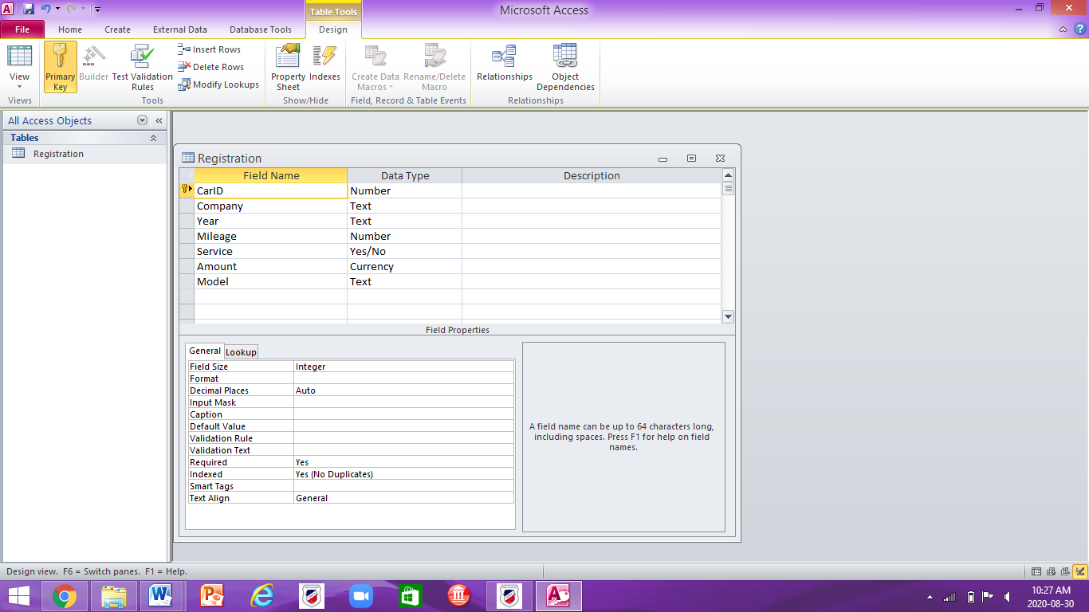**Database**

The user will be able to search through the database to find the car that suits him best. They can then order that car and their name will be added to the text file. A brief summary of the purchase will be displayed and the total after commission. Thereafter the listing will be removed.

**Array**

The array will be used to generate a random code and it will assign it to the user’s name. The code will be used in the giveaway. 1 array for numbers.1 array for letters

**Text file**

The text file will store the user name and the details as well as their order. If the user buys a car they will receive a random code. The code will be used to decide the winner for of the prize.

**DATA INPUT**

**Array**

The array will be used to generate a random code and it will assign it to the user’s name. The code will be used in the giveaway. 1 array for integer.1 array for string.

**The Age**

The checkbox on tabsheet 2 will use Boolen to get answer. The use will either be over 18 or under 18 years of age.

The system will check to see if it is checked. If the box is not checked then the person will not be allowed to proceed to the next tabsheet. A error message will pop up.

**Total**

On Tab sheet 4, the admin use will be able to summarise there revenue. This value will use be real. It get this information from the database.

**Model or Make of the vehicle**

A combo box, that is found on the tabsheet 2 which is used to filter, will be used with pre listed strings The use must pick one of the opions.

**Validation**

**The Age**

The system will check to see if it is checked. If the box is not checked then the person will not be allowed to proceed to the next tabsheet. A error message will pop up.

**Email**

The system will check to see if there is an ‘@’ sign in the email adress. If not then an error message will be displayed saying that the email adress is not valid

**Year**

The system will check to see if the user enters a year that is less than 2021. If the value is more than 2021 then an error message will be displayed and the user must re enter a year.

**Data Processing**

**Searching**

The user must search through the database for :

1. Model- string from combo box
2. Year- integer from spin edit
3. Price- Integer from edit boxes
4. Transmission through the combo box

The search will use code

**Generating Random**

1. Array of string. Generating random letters from A to Z.
2. Array of integer. Generation random letters from 1 to 9.

**Total Revenue**

The total revenue will read through the text file and it will add all the values. This will use the Read line function and a total will be displayed.

**Total Number of Sales**

The total number of sales will read through the text file . This will use the Read line function and a counter and the number of the counter will be displayed will be displayed.

**Data Output**

**DB Grid**

The db grid will display the database as well os the filtered database. These filters will come edit boxes and combo boxes.

**Show message from random function**

A showmessage will display the random code that the user will be given. This will use the random function and will be stord in the text file

**Total Revenue**

The total revenue will read through the text file and it will add all the values. This will use the Read line function and a total will be displayed.

**Order Pre view in the rich edit**

The order pre view wil be displayed on the rich edit. This will come from the database. What ever the user picks will be displayed there after processin

**Navigation and Flow Diagram/ GUI Design**

**User INPUT / PROCESS / OUTPUT**

**FLOW DIAGRAM OF RUNNING THE PROGRAM FOR ADMIN USER**

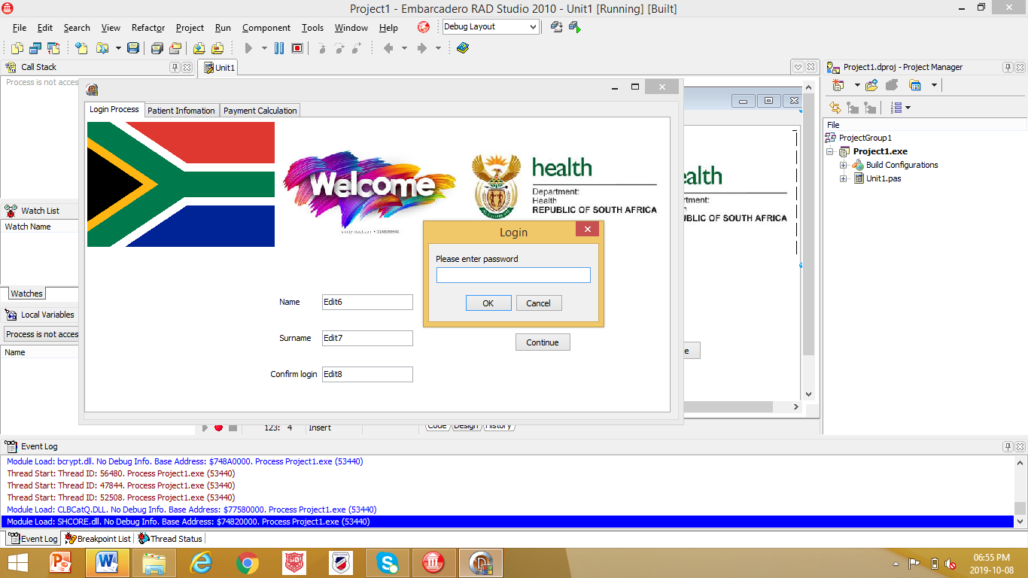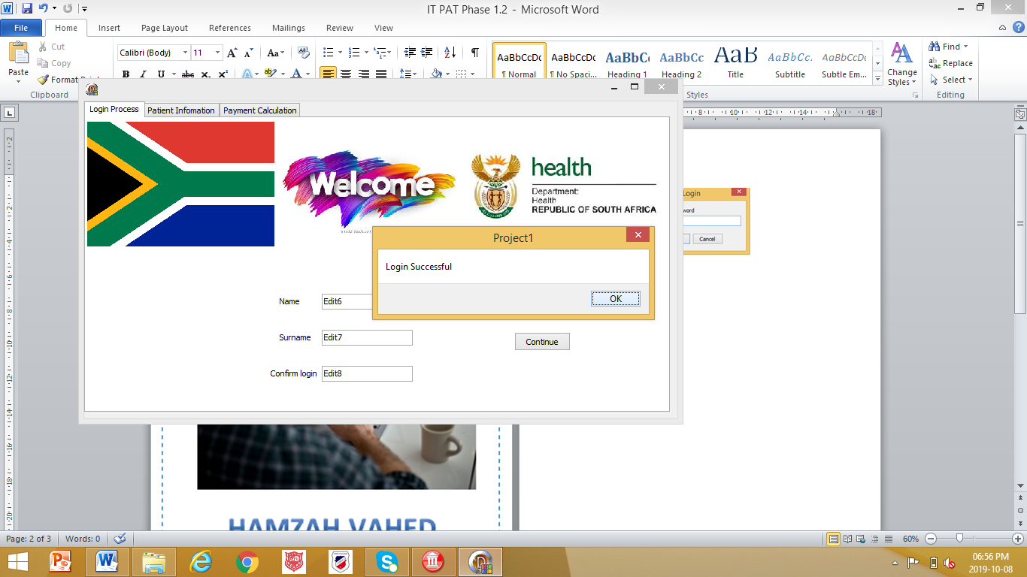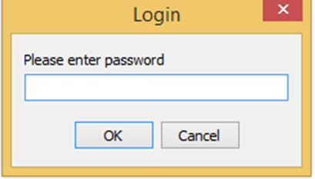

The user must enter a password.

This process will repeat itself

IF YES / Correct

If NO / Incorrect

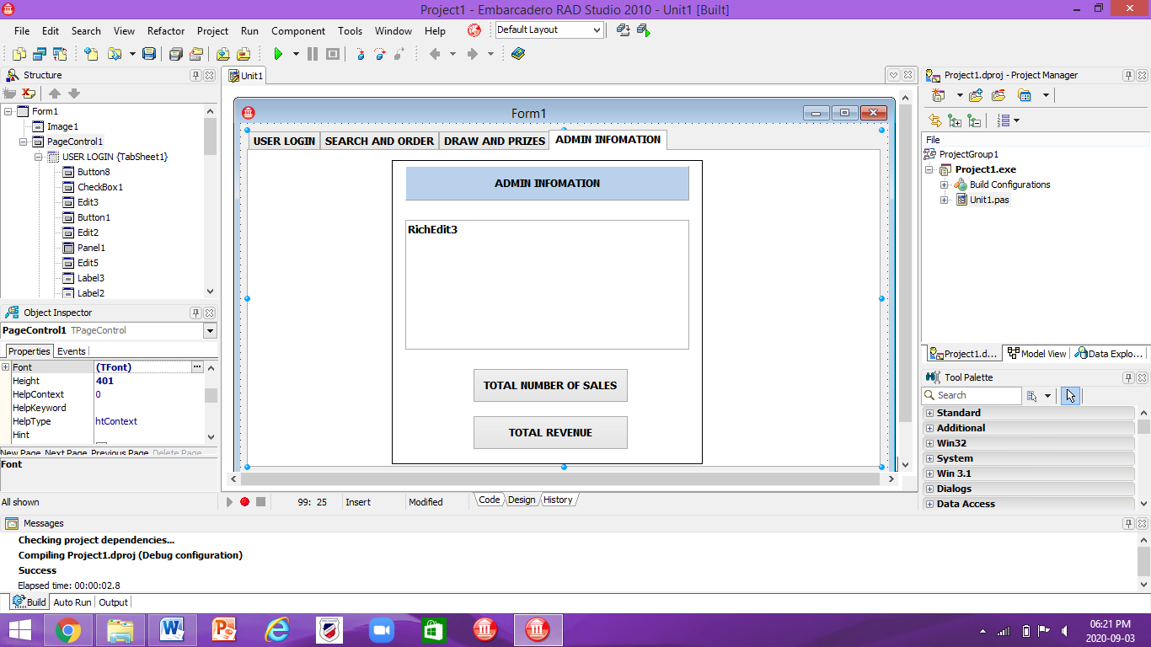

Home Page

* Tab sheet 4

**User Identification Process**

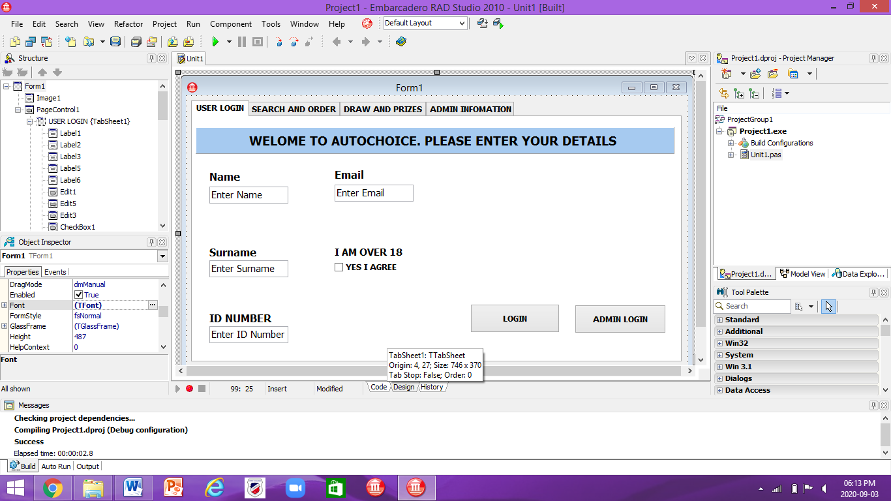

Input:

The user will inut their personal information into input boxes.

Process:

When the button ‘continue’ is pressed, the program will then process the information and it will recognize the user’s authorization and will grant access to the user.

Output:

If the data entered is correct, the program will automatically change to the second tabsheet. If not a show message will pop up.

**Search and Order**

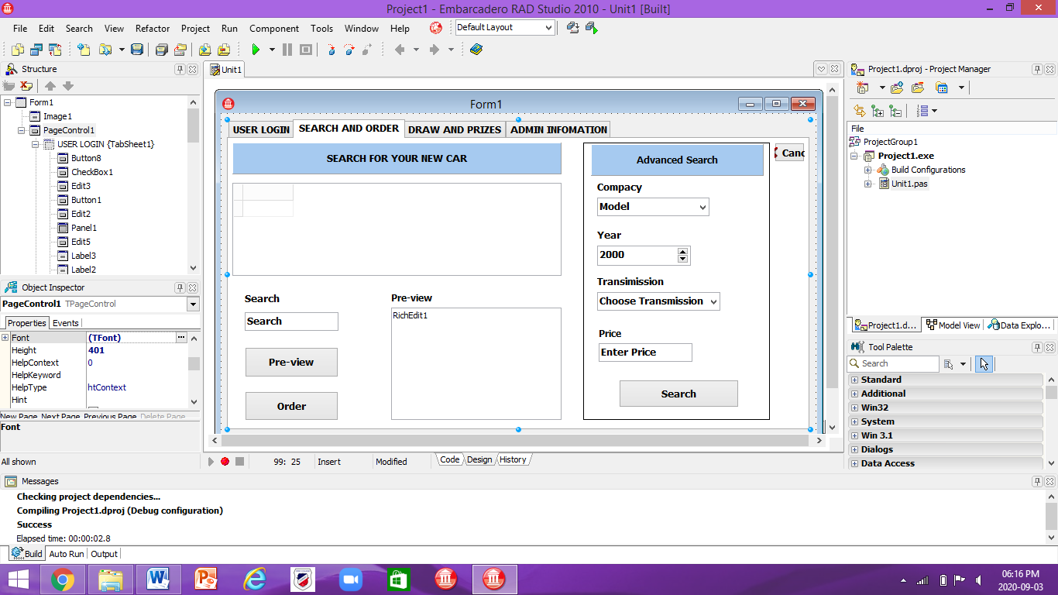

Input:

The user will enter various data’s into the edit boxes as well as spin edits and combo boxes.

Process:

When the button is pressed it will search through the database and the data will appear in the rich edit.

Output:

There will be a solution displayed. The user then can order that car or leave. It will copy to a text file.

**Lucky Draw and Prizes**

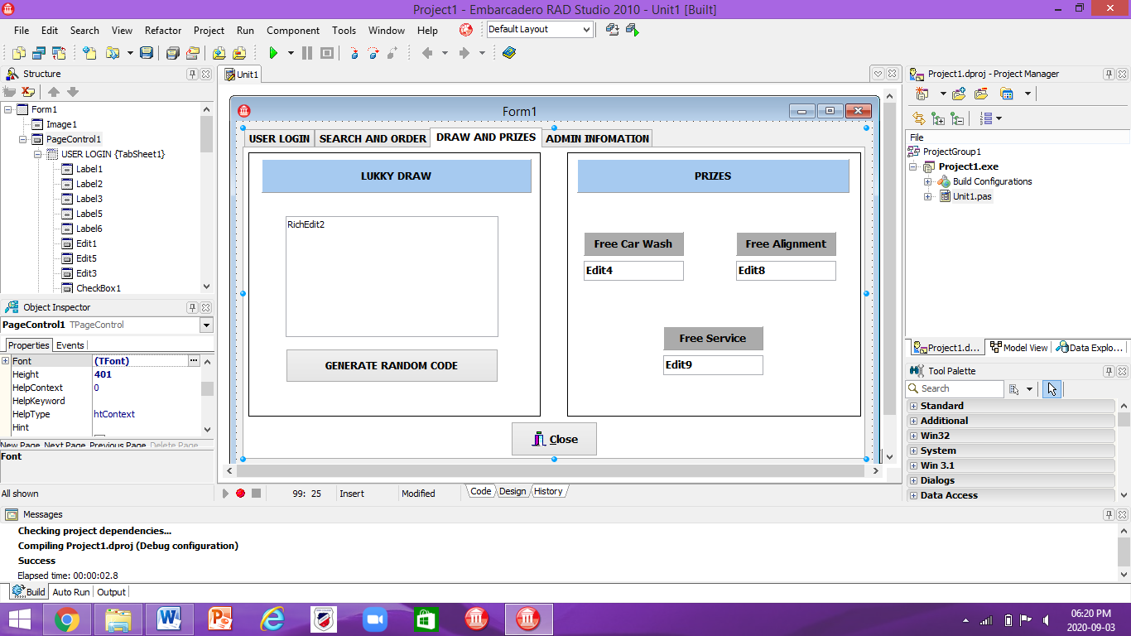

Input:

The user orders a car they will be given access to this tab sheet.

Process:

When the button is pressed a random code will be generated and assigned to the user. The system will check to see if that code is valid for a prize.

Output:

There will be a solution displayed. It will copy to a text file.

**Admin Information**



Input:

The user is an admin they will be given access to this tab sheet. The can choose to see amount of sales

Process:

When the button is pressed the program will read through the text file and add up all the values.

Output:

There will be a solution displayed.